UCLID Software

Software Development Process

Defect Tracking Procedure
Table of Contents

Overview 3
Roles and responsibilities 4
Developer 4
Test administrator 4
Tester 4
Recording defects / enhancements 4
Defect existence verification / enhancement validation 4
Fixing defects / incorporating enhancements 4
Making internal software releases 4
Defect fix / enhancement verification 4
Closing of defects / enhancements 4
Other issues 5
Re-opening defects / enhancements 5
Duplicate defects / enhancements 5
Postponing enhancements 5

Overview
The purpose of this document is to outline the procedure that UCLID Software developers and testers will follow in order to facilitate efficient software development and testing. This document summarizes the various roles that play a part in the defect tracking procedure, the respective responsibilities of the various roles, as well as the details associated with each step in the defect tracking procedure.
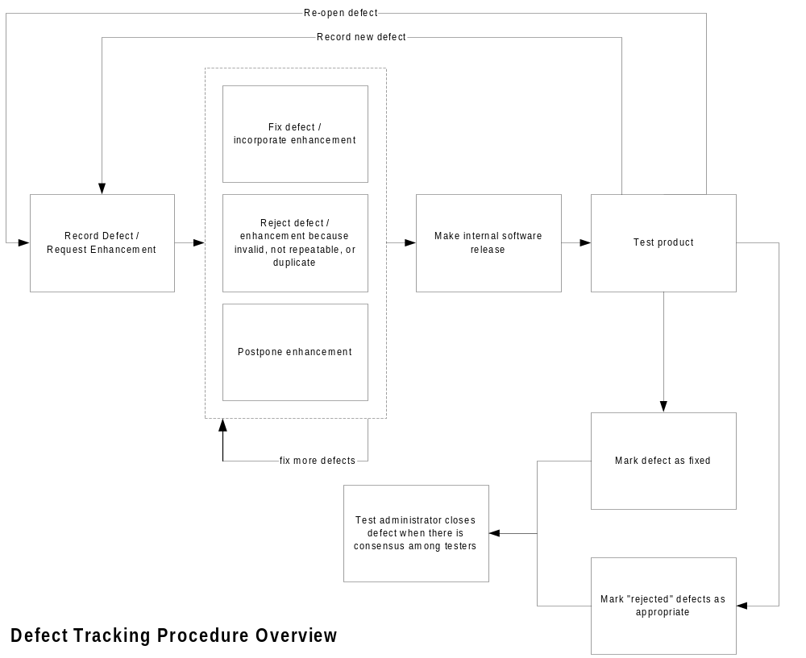

A summary of the defect tracking procedure is as follows: When anyone finds a defect in the current release of the product (which could be an internal release), they record a defect in the defect tracking system. Product enhancements can be requested via the same mechanism. The developers evaluate the various recorded defects and enhancement requests and for each record do one of the following: they fix the defects or incorporate the requested enhancement; or they “reject” the defect on the grounds that it is invalid, not repeatable, not applicable, or a duplicate record; or, in the case of an enhancement request, developers can choose to mark the record as postponed. Once enough modified functionality has been introduced into the product, the developers make an internal release of the product. The testers begin testing the new release and do the following: record new defects that they find; for each defect/enhancement that was fixed/introduced in the particular release, the testers either mark the record as fixed, rejected, duplicate, not repeatable, or not applicable. If the testers encounter a defect that the developers claim to be fixed, the testers can follow the prescribed procedure to re-open a defect. Once there is consensus among at least three testers on a particular defect/enhancement record, the test administrator closes the record.

Roles and responsibilities
The following are the various roles and their respective responsibilities in the scope of the defect tracking procedure.

Developer
The developer’s primary responsibility is fixing recorded defects, as well as incorporating requested enhancements. A developer develops one or more of a variety of products such as application software, installation software, technical documentation, etc.

Tester
The tester’s primary responsibility is evaluating the quality of the end product in terms of formal and/or informal testing. Formal testing refers to following a documented methodical and systematic testing process whereas informal testing refers to testing of the software by means of using it as a user would.

Test administrator
The test administrator’s primary responsibility is setting up the defect tracking software to implement the defect tracking procedure, as well as to performing other administrative tasks documented in the defect tracking procedure.

Recording defects / enhancements
Why record a defect / enhancement request?
Who can record defects?
What fields need to be updated? Mandatory vs. optional
Ads

Defect existence verification / enhancement validation
Ads

Fixing defects / incorporating enhancements
Ads

Making internal software releases
Asd

Defect fix / enhancement verification
Asd

Closing of defects / enhancements
Asd

Other issues

Re-opening defects / enhancements
asd

Duplicate defects / enhancements
Asd

Postponing enhancements
Sad

